

Investigating the maths inside:

Bees with backpacks

Activity 6

Bee patterns

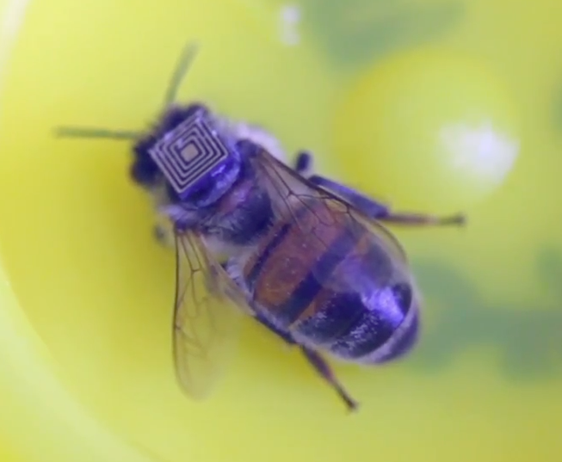

Why do some shapes tessellate like the cells in a beehive?

# Introduction

This is a diagram of a honeycomb drawn approximately life-size. How big is a honey bee?

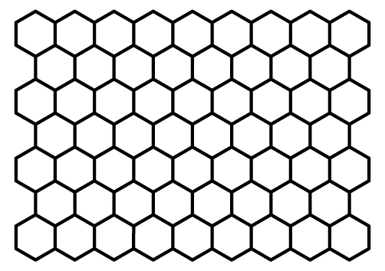

Bees construct the cells with vertical ‘walls’. The ‘floor’ and ‘ceiling’ are sloped.

# Beehive geometry

## Drawing a regular hexagon

Use a compass to draw a circle with a radius of 6 cm and label the centre O. Keep the compass adjusted to the radius of the circle.

Choose any point on the circle and label it A. Put the point of the compass on A and mark off an arc where it intersects the circle. Label this point B.

Put the point of the compass on B and mark off an arc where it intersects the circle. Label this point C.

Continue around the circle. Label the points D, E and F. If you do this accurately, the last arc should intersect the circle at the point A.

Connect the points in order.

How accurate were you? Check to see how close to regular your hexagon is.

## Why?

Look at the beehive drawing. Why do you think regular hexagons tessellate?

Do all regular polygons tessellate?

# The quadrilateral challenge

## A convex tessellation

On a piece of square grid paper, create a convex quadrilateral with all sides different lengths. Draw at least eight exactly the same. Mark the lines thickly. Shade or colour half of them. Cut them out carefully.

Can you arrange them so that they tessellate? What do you have to do to the pieces to tile the plane?

Glue your tessellation onto a piece of card.

## What about a concave tessellation?

Do the same activity but this time create a concave quadrilateral with all sides different lengths.

Can you arrange them so that they tessellate? What do you have to do to the pieces to tile the plane?

Glue your tessellation onto a piece of card.

## Explain it!

Why do all quadrilaterals tessellate? Can you explain?

# Tiling patterns

Your teacher will provide a sheet printed with some regular polygons. Cut out the shapes.

Working in groups, can you use two ***differen****t* regular polygons to ‘tile’ an object? You can use as many of each polygon as you like. Record your solutions.

What about three different regular polygons? Record your solutions.

## Angle investigation

Choose your favourite tiling pattern (tessellation) and explain why it works. You will need to know about the angles of your shapes.