

Investigating the maths inside:

Maths in 3D

Activity 2

Are we there yet?

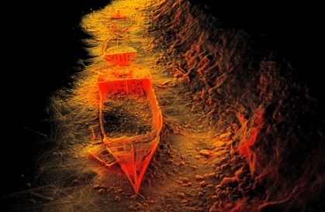

How are distance, time and speed connected?

A family is in their car travelling on a long drive as part of a holiday.

A voice from the back seat says, “Are we there yet?”

Dad says, “No. We have 70 km to go.”

The car is going at roughly 90 km/h (Dad is a very careful driver).

How long will it be before they get to their destination?

# Estimation

Working in pairs (and without using a calculator or a formula or recording calculations) make an estimate of the answer.

Share your strategy with other class members.

# Calculation

You can also use a formula 

where *s* is the speed, *d* is the distance and *t* is the time.

Substituting values into the formula 

where *90 km/h* is the speed, *70 km* is the distance and *t* is the time (which is what we want to find out).





Multiply both sides by *t* 90*t* = 70

Therefore 

Therefore *t* = 0.77777…

This means the time remaining is a little more than three quarters of an hour or, more precisely, 47 minutes (0.77777… × 60 = 46.66666…)

Alternatively, we can rearrange the formula first

time (*t*) = distance (*d*)/speed (*s*) 

# Try these

1 Flying bats use a similar technique to the Zebedee to ‘see’ in dark places. While the Zebedee uses laser light, the bats emit sound waves. They interpret the echo to tell how far away an object is, as well as its size and texture, and whether it is moving.

The speed of sound is 344 metres per second. How long does the sound wave emitted from the bat take to return to the bat after hitting a wall 30 metres away?

Zoologists using the Zebedee 3D mapping of a cave calculate two points 180 metres apart. They note that it takes a bat 1.4 seconds to fly between the two points.

What is the average speed of the bat in kilometres per hour?

3 During an electrical storm, we see the lightning first then hear the thunder.

Sound travels at 344 metres per second.

Assume that the lightning is seen instantaneously. Why is this a sensible assumption?

Complete the following table to find the distance from the lightening strike by using the time for the thunder to be heard.

|  |  |  |  |  |  |
| --- | --- | --- | --- | --- | --- |
| Time taken to hear thunder (in s) | 0 | 1 | 2 | 3 | 4 |
| Distance from lightning strike (in km) | 0 |  |  |  |  |

Use the table to describe a rule that will explain how far you are away from a lightning strike if you count the time between the lightning strike and the sound of thunder in seconds.

4 Choose a location about 50 km from where you live. You are planning to drive there.

State where the location is and explain how you determined the distance.

Estimate your average speed. Detail the nature of travel conditions, type of roads, speed limits, and any other factors that contributed to your estimate.

Estimate the time it would take to get to the location.

Plan an alternative route and compare the two routes. Are they the same distance? Do they take the same time? Which one would you choose and why?