

Investigating the maths inside:

Stargazing with the SKA

Activity 4

Seeking spirals

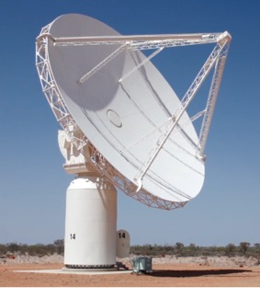

Why spirals?

# Introduction

There are many beautiful designs in nature. Spirals occur naturally in many places, such as flowers and plants.

One of the most beautiful spirals occurs in the shell of the chambered nautilus, a sea creature that lives in the South Pacific. As the nautilus grows, it builds and moves through a series of ever-larger chambers. Each chamber has the same shape as the one before it.

The photograph below shows the shell of a chambered nautilus that has been cut in half to reveal the chambers.

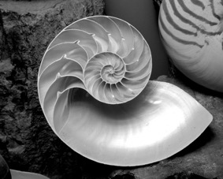

A spiral is a curve traced by a point that moves around a fixed point. The moving point gets further and further away from the fixed point.

# Archimedean spirals

The Archimedean spiral has loops spaced at equal intervals. It is named after Archimedes, who lived in the third century BC and wrote a book on spirals.

The groove of a vinyl record is an Archimedean spiral. Because of the equal spacing, the successive distances of the loops from the centre of the spiral form an *arithmetic sequence.* For example: 0, 4, 8, 12, 16…



# Logarithmic spirals

The curve of the shell of the chambered nautilus is a logarithmic spiral.

The loops of a logarithmic spiral are spaced further and further apart as they wind outward from the centre. The successive distances from the centre form a *geometric sequence.* For example: 1, 3, 9, 27, 81 ….

The logarithmic spiral was discovered by Renee Descartes who was born in France in the late-sixteenth century.



# History corner

Find out more about Archimedes and Renee Descartes. When were they born and where did they live?

Mathematically, what is each most famous for?

Spirals can be found in many different situations, particularly in nature. Some examples are heads of daisies, the internal parts of the ear that sense sound, and webs of spiders. Most galaxies have a spiral shape, including the Milky Way, the galaxy that contains our solar system.

# Finding spirals

Find five examples of spirals and identify whether they are examples of Archimedean or logarithmic spirals.

# Drawing spirals 1

To draw spirals we need to use polar graph paper, which will be provided by your teacher.

What do you notice about this kind of graph paper?

Use the information in the table below to plot the points on polar graph paper.

|  |  |  |  |  |  |  |
| --- | --- | --- | --- | --- | --- | --- |
| Angle (in degrees) | 0 | 30 | 60 | 90 | 120 | 150 |
| Distance from centre (in cm) | 0 | 1 | 2 | 3 | 4 | 5 |

Connect the points in order with a smooth curve.

Is this an Archimedean or logarithmic spiral? How do you know? Did you need the graph to determine this?

What patterns can you see in the table?

Use the pattern to extend the table. How many times around do you need to go for you to decide what kind of spiral it is?

# Drawing spirals 2

Plot the points on polar graph paper. Connect the points in order with a smooth curve.

|  |  |  |  |  |  |  |  |  |  |  |  |  |  |  |  |
| --- | --- | --- | --- | --- | --- | --- | --- | --- | --- | --- | --- | --- | --- | --- | --- |
| Angle in degrees | 0 | 30 | 60 | 90 | 120 | 150 | 180 | 210 | 240 | 270 | 300 | 330 | 360 | 390 | 420 |
| Distance from centre in cm | 0.5 | 0.55 | 0.6 | 0.65 | 0.7 | 0.8 | 0.85 | 0.95 | 1.05 | 1.15 | 1.25 | 1.35 | 1.5 | 1.65 | 1.8 |
| Angle in degrees | 450 | 480 | 510 | 540 | 570 | 600 | 630 | 660 | 690 | 720 | 750 | 780 | 810 | 840 | 870 |
| Distance from centre in cm | 1.95 | 2.15 | 2.35 | 2.6 | 2.85 | 3.2 | 3.4 | 3.75 | 4.1 | 4.5 | 4.95 | 5.4 | 5.9 | 6.5 | 7.2 |

Is this an Archimedean or Logarithmic spiral? How do you know?

# Drawing spirals 3 (using technology)

This interactive allows you to change the shape of a logarithmic spiral.

[www.integralprogram.org/index.php/academics5924d/resourcesc5a6c/laboratory/freshman-lab/logarithmic-spiral-from-geogebra/97-laboratory/freshman-lab](http://www.integralprogram.org/index.php/academics5924d/resourcesc5a6c/laboratory/freshman-lab/logarithmic-spiral-from-geogebra/97-laboratory/freshman-lab)

This spiral was drawn using the software The Geometer’s Sketchpad. A trial version can be downloaded for free from: <http://info.mheducation.com/sketchpad.trial.html>.

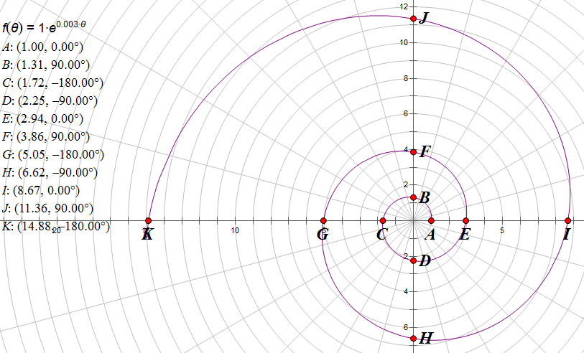

# Placing the telescopes

It is important that all telescopes are not placed at the same distance from each other. The data provided by using two sets of telescopes that are the same distance apart will be identical and will not add to the amount of data available.

Scientists believe that placing the telescopes in a spiral arrangement will minimise redundancy.

This webpage provides information about the arrangment of the telescopes in the Square Kilometre Array: <https://www.skatelescope.org/layout/>

# Random arrangement by hand

Place five dots (representing telescopes) randomly on a piece of A4 paper, labelling the five points A, B, C, D and E.

Measure the distance between the points to the nearest centimetre and record your measurements in the table below.

|  |  |  |  |  |  |
| --- | --- | --- | --- | --- | --- |
| Distance from to | A | B | C | D | E |
| A | 0 |  |  |  |  |
| B |  | 0 |  |  |  |
| C |  |  | 0 |  |  |
| D |  |  |  | 0 |  |
| E |  |  |  |  | 0 |

Why are some parts of the table shaded?

How many distances are equal (to the nearest cm)? Compare your results with others.

How many students ended up with no repeated distances? What percentage is this?

# Random arrangement using Spreadsheet A

To select points on a plane, it is easier to describe the points using a Cartesian plane like the one below. For our situation, the scale on both the x-axis and the y-axis will go from 0 to 100.



Ten telescopes will be located on the Cartesian plane, their positions described with whole numbers, for example (57, 89).

There are 101 numbers on the x-axis and 101 numbers on the y-axis, so there are 101 × 101 = 10 201 different places to locate each telescope.

If the telescopes are placed randomly, and the distance between every pair of points is calculated, estimate the chance that two or more of those distances will be equal.

Spreadsheet A generates 10 points at random and then calculates the distance between each pair of points. If two or more distances are equal they will be highlighted pink.

What formula is used to find the distance between two points?

Refresh the spread sheet 50 times, recording how many distance repeats there are in each of the 50 trials.

How many of the trials did not have any distance repeats? Express this as a percentage.

Was it higher or lower than your estimate?

# Spiral arrangement using Spreadsheet B

Spreadsheet B uses the coordinates from the logarithmic spiral drawn earlier.

Columns 1 and 2 hold the polar coordinates. Columns 3 and 4 hold the Cartesian coordinates.

How are the polar coordinates converted to Cartesian coordinates?

The tables display the distances between 10, 20 and 30 points on the spiral. Refresh the spreadsheet 50 times. What do you observe?

Does using using a spiral produce points that are less likely to be equidistant from other points?