

Investigating the maths inside:

Stargazing with the SKA

Activity 2C

Things that go very fast

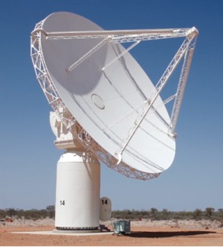

How big is a gigabyte?

How fast is the Earth moving?

# How much data?

The Square Kilometre Array will collect vast amounts of data. It is estimated that the data collected by the SKA in a single day would take nearly two million years to playback on an iPod.

Use the internet to research the following:

* What is a bit?
* What is a byte?
* What is a kilobyte?
* How many kilobytes in a megabyte?
* How many megabytes in a gigabyte?
* What words are used for larger quantities?

|  |  |
| --- | --- |
| This video shows some of the first devices that were used to store data.  www.youtube.com/watch?v=hQWcIkoqXwg |  |

# Counting in base 10 and base 2 (binary)

Complete the table, which shows the first 32 integers in base 10 and base 2.

|  |  |  |  |  |
| --- | --- | --- | --- | --- |
| **Base 10** | **Base 2** |  | **Base 10** | **Base 2** |
| 1 | 1 |  | 17 |  |
| 2 | 10 |  | 18 |  |
| 3 | 11 |  | 19 |  |
| 4 | 100 |  | 20 |  |
| 5 | 101 |  | 21 |  |
| 6 | 110 |  | 22 |  |
| 7 | 111 |  | 23 |  |
| 8 | 1000 |  | 24 |  |
| 9 | 1001 |  | 25 |  |
| 10 | 1010 |  | 26 |  |
| 11 |  |  | 27 |  |
| 12 |  |  | 28 |  |
| 13 |  |  | 29 |  |
| 14 |  |  | 30 |  |
| 15 |  |  | 31 |  |
| 16 | 10000 |  | 32 | 100000 |

The ‘byte’ you saw in the video held 8 tubes, each of which could be switched on or off.

This means that the number of different states is 2 to the power of 8, which is 256.

# Paper-folding to the moon

How many times would you have to fold a (very large!) piece of paper until it was thick enough to reach to the moon?

## Measuring and calculating

Measure the height in millimetres of a stack of 500 sheets (1 ream) of copier paper. How thick is one sheet? It should be less than one millimetre.

Take one sheet of paper and fold it in half. You now have two ‘layers’ of paper. Calculate the thickness.

Fold it in half again. You now have 4 ‘layers’ of paper. Calculate the thickness.

## Estimating

Estimate the number of times you would need to fold the paper until it becomes as tall as you.

Estimate the number of times you would need to fold the paper to reach between the Earth and the moon.

## Calculating with a spreadsheet

Open a spreadsheet and set it up like the one below. If in doubt, there is an instructional video you can watch at https://youtu.be/THgZHoNiMcs.

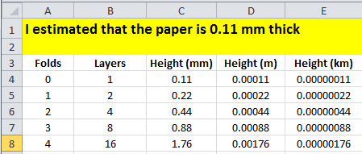

Use the spreadsheet to calculate the number of times you would need to fold the paper to make it as tall as you. Is this more or less than you estimated?

Use the spreadsheet to calculate the number of times you would need to fold the paper to reach between the Earth and the moon. Is this more or less than you estimated?

How many more folds would it take to reach the Sun?

# The ‘things that go really fast’ experiment

“I’m so fast, last night I turned off the light switch in my hotel room and was in bed before the room was dark.”

Muhammad Ali (arguably the greatest boxer of all time)

## Speeds

The speed of light is 299 792 458 metres per second. How long will it take light to travel 200 metres?

The speed of sound at sea level is 340.29 metres per second. How long will it take sound to travel 200 metres?

## The experiment

This experiment compares the speed of light with the speed of sound.

Select two positions, possibly on the school oval, that are several hundred metres apart. The positions need to have a direct line of sight between them. Make the distance between the positions as large as possible.

Use a trundle wheel to measure the distance between them.

Have the stopwatch on your mobile phone ready.

An adult will fire a starting pistol, or simultaneously blow a whistle and turn on a torch.

Press ‘start’ when you see the light and press ‘stop’ when you hear the sound.

Try it several times and compare results.

## Thunderstorm

Next time a thunder storm is approaching, try to predict the distance from you to the lightning.

* Press ‘start’ when you see the lightning
* Press ‘stop’ when you hear the thunder
* Multiply the time in seconds by 340.29 to get the answer in metres.

# Other things that go really fast

How fast is the Earth travelling through space?

How fast are you rotating around the Earth’s axis?

How fast do satellites travel around the Earth?

How fast does Halley’s Comet travel?

How fast do protons travel in the Large Hadron Collider?

How long does it take for light to travel from the Sun to the Earth?

How long does it take for light to reach us from the nearest star other than the sun?

How long would it take to travel from Earth to the nearest star at a speed of 100 km/h?

# Satellite spotting

Have you ever noticed a satellite travelling across the night sky?

This website allows you to enter your location and then tells you when to look, in what part of the sky and what you are looking at.

www.heavens-above.com