Density and Rotational Period of a Pulsar
Most stars in the mass range between 1.4 and 8 solar masses will end up as a neutron star. As a star collapses, the pressure is so great that individual protons and electrons combine to form neutrons and ultimately a neutron star whose density is so great a thimble full would weigh as much as 10 billion tonnes.
As the neutron star contracts, its angular momentum causes it to speed up, just as an ice skater speeds up as they bring their arms to their side. Once the collapse is complete, the pulsar will spin at roughly a constant rate, making them the most accurate clocks in the Universe. The periods of 1,900 catalogued pulsars range from a few milliseconds to a few seconds. (See figure 1) Almost all of these pulsars have been observed to be slowing down so their periods are (ever so slowly) increasing with time. For example, the Crab pulsar is slowing down by 38 nanoseconds per day or 1.4 seconds over 100,000 years.
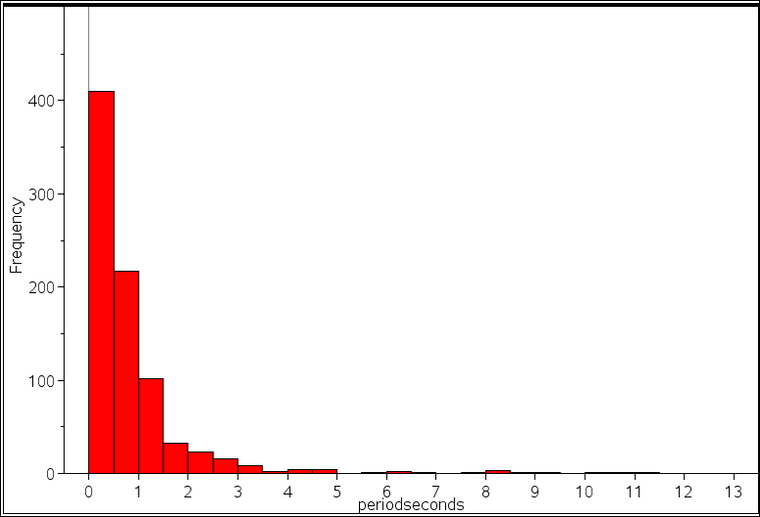
figure 1
Density of a pulsar
A typical pulsar has a mean density of 6.7 x 10¹⁴ grams/cm³which is equivalent to a single sugar cube weighing as much as all of humanity (approximately the weight of 7 billion people)
Density which has the symbol ρ, (the Greek letter rho) is determined by dividing the mass of an object by its volume. [density = $\frac{mass}{volume}$ ] The volume of most celestial objects can be approximated by using the equation for the volume of a sphere. [V = $\frac{4}{3} πr^{3}$]
For example, the Sun has a mass of 1.998 x 10³⁰ kg and a radius of 696,265,000 metres. What is the density of the Sun in grams/cm³?
First determine the volume of the Sun in cubic metres.
V =$\frac{4}{3}πr^{3}$
=$\frac{4}{3} π ×{696,265,000 }^{3}$
= 1.41388 x 10²⁷ m³.
Density = $\frac{mass}{volume}$
= $\frac{1.998 × {10}^{30}}{1.41388 × {10}^{27}}$
= 1413.13 kg/m³ or 1.413 grams/cm³.
Question 1
- Determine the mean density of the following Solar system objects.
Planet | Radius (kilometres) | Mass $×$(10²⁴ kg) | Mean density (gm/cm³)
Mercury | 2440 | 0.330
Venus | 6050 | 4.869
Earth | 6380 | 5.974
Mars | 3390 | 0.642
Jupiter | 71400 | 1898.8
Saturn | 60000 | 568.50
Uranus | 25400 | 86.625
Neptune | 25300 | 102.78
Moon | 1740 | 0.0735

- Compare the density of the four inner planets (Mercury, Venus, Earth and Mars) with the four gas giants-Jupiter, Saturn, Uranus and Neptune. Comment on your findings.
- Which one of the planets would float in an ocean big enough to contain it?

Rotational period of a pulsar
Based on the statistical distributions of stellar masses, 95% of all stars will end their lives as white dwarfs, including our Sun. Suppose our Sun could be compressed to form a neutron star or pulsar; what is its radius and period ?
The volume of the Sun when compressed to a neutron star is determined by using the density of a neutron star (6.7 x 10¹⁴ grams/cm³) and the Sun’s mass of 1.998 x 10³⁰ kg.
density = $\frac{mass}{volume}$
6.7 x10¹⁴ = $\frac{1.998 ×{10}^{30 }×1000 gm}{V}$
V = $\frac{1.998 ×{10}^{33}}{6.7 × {10}^{14}}$
= 2.982 x 10¹⁸ cm³
Next substitute the volume into the formulae and find the radius.
V =$\frac{4}{3}πr^{3}$
2.982 x 10¹⁸ = $\frac{4}{3}πr^{3}$
r = $\sqrt[3]{\frac{2.982 × {10}^{18}× 3}{4π}}$
r = 892907 cm or 8.93 km
The Sun has a rotational period of 25 days; however, as a neutron star its rotational period will be much quicker since angular momentum is conserved.
For example, if the Sun’s diameter suddenly halved, its rotational period would be one quarter ($\frac{1}{2^{2}})$ of 25 days or 6.25 days. If its radius suddenly halved again, its rotational period would be 1.56 days.
This is illustrated below in figure 2.
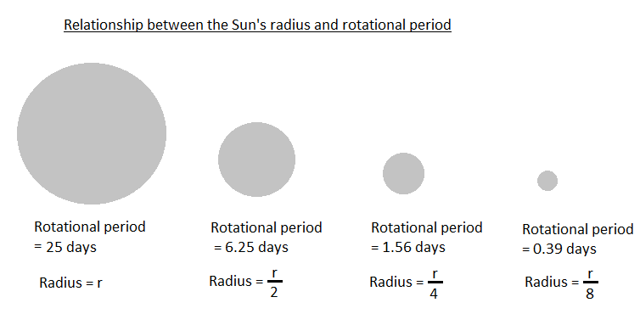
figure 2
The ratio of the periods equals the ratio of the radii squared. This can be represented mathematically as:
$\frac{p_{1}}{p_{2}}= \frac{{r_{1}}^{2}}{{r_{2}}^{2}}$
The Sun’s period is normally is 25 days. As a neutron star its period is found by substituting into the formulae.
$\frac{p_{1}}{25}= \frac{{8.93}^{2}}{{696265}^{2}}$
p = $\frac{{8.93}^{2}}{{696265}^{2}} ×25$
= 0.0000000041 days or 0.000355 seconds
This means the Sun would rotate 2,817 times per second. ( $\frac{1}{0.000355}$ = 2,817)Therefore the frequency is 2,817 Hertz. (2,817 Hz)
Question 2
(i) The Sun will actually end its stellar evolution as a white dwarf, which is about the size of the Earth. (radius = 6,378 kilometers) Determine the density (in g/cm³) and the rotational period of the Sun as a white dwarf. Compare its density and period as a white dwarf to its original density and period. [This is assuming that the Sun doesn’t lose any mass during its stellar demise]

- Determine the radius, rotational period and frequency for the Earth if it were hypothetically compressed to form a pulsar. Assume the density of the Earth as a pulsar is 6.7 x 10¹⁴ grams/cm³.

- Determine the radius, rotational period and frequency for each of the celestial objects below if they could be hypothetically compressed to form a pulsar. Assume the density of each pulsar is 6.7 x 10¹⁴ grams/cm³.

Planet | Radius (kilometres) | Mass $×$(10²⁴ kg) | Mean density (gm/cm³) | Rotational Period  (days) | Radius as a pulsar (km) | Rotational period  (milliseconds) | Frequency  (Hz)
Mercury | 2440 | 0.330 | 5.43 | 58.6
Venus | 6050 | 4.869 | 5.24 | 243
Earth | 6380 | 5.974 | 5.515 | 1
Mars | 3390 | 0.642 | 3.94 | 1.026
Jupiter | 71400 | 1898.8 | 1.33 | 0.414
Saturn | 60000 | 568.50 | 0.70* | 0.438
Uranus | 25400 | 86.625 | 1.3 | 0.65
Neptune | 25300 | 102.78 | 1.76 | 0.768
Moon | 1740 | 0.0735 | 3.94 | 29.5

Answers
Question 1
(i)
Planet | Radius (kilometres) | Mass $×$(10²⁴ kg) | Mean density (gm/cm³)
Mercury | 2440 | 0.330 | 5.42
Venus | 6050 | 4.869 | 5.24
Earth | 6380 | 5.974 | 5.62
Mars | 3390 | 0.642 | 3.93
Jupiter | 71400 | 1898.8 | 1.25
Saturn | 60000 | 568.50 | 0.63*
Uranus | 25400 | 86.625 | 1.3
Neptune | 25300 | 102.78 | 1.52
Moon | 1740 | 0.0735 | 3.33
*Density of Saturn is less than the density of water.
(ii) The four inner planets are at least three times denser than the four outer planets.
- Saturn would float in an ocean since its density (0.63 grams/cm³) is less than the density of water.(1 gram/cm³)

Question 2
- Volume (earth) in cm³ = $\frac{4 ×π ×({6,378 ×10 00 ×100)}^{3}}{3}$ = 1.08678 x 10²⁷ cm³
Density (Sun in g/cm³) = $\frac{mass}{volume}$ = $\frac{1.998 × {10}^{30}×1,000}{1.08678 × {10}^{27}}$= 1.838 $× {10}^{6}$ g/cm³.
The density has increased by a factor of 1,300,780 $(\frac{1.838 ×{10}^{6}}{1.413}$) and the rotational period has decreased by a 6.098 x 10⁹ ($\frac{25}{4.1 ×{10}^{-9} }$ )
- Density of the Earth as a pulsar = $\frac{mass}{volume}$
6.7 x 10¹⁴ grams/cm³ = $\frac{5.974 × {10}^{24} ×1,000 grams}{V}$
V = $\frac{5.974 × {10}^{24} ×1,000}{6.7 × {10}^{14}}$ = 8.916 x 10¹² cm³

V = $\frac{4}{3}πr^{3}$
r = $\sqrt[3]{\frac{3 ×8.916 ×{10}^{12}}{4×π}}$
r = 12863.5 cm
r = 128.6 m

Rotational period of the Earth as a pulsar.
$$\frac{p_{1}}{p_{2}}= \frac{{r_{1}}^{2}}{{r_{2}}^{2}}$$
$$\frac{p}{1 day}= \frac{\left({128.6}^{2}\right)}{{ \left(6,380 ×1,000\right)}^{2}}$$
$$= 4.0629 ×{10}^{-10}days$$
$$=0.000035 seconds or 35 micro seconds$$
Frequency = $\frac{1}{period}$
$=\frac{1}{0.000035}$
= 28,571 Hz (the Earth would rotate 28,571 times a second)
(iii)
Planet | Radius (kilometres) | Mass $×$(10²⁴ kg) | Mean density (gm/cm³) | Rotational Period  (days) | Radius as a pulsar  (km) | Rotational period  (milliseconds) | Frequency  (Hz)
Mercury | 2,440 | 0.330 | 5.43 | 58.6 | 0.049 | 2.044 | 489
Venus | 6,050 | 4.869 | 5.24 | 243 | 0.012 | 8.29 | 120
Earth | 6,380 | 5.974 | 5.515 | 1 | 0.128 | 0.035 | 28,571
Mars | 3,390 | 0.642 | 3.94 | 1.026 | 0.612 | 0.290 | 34,608
Jupiter | 71,400 | 1898.8 | 1.33 | 0.414 | 0.880 | 0.00543 | 184,055
Saturn | 60,000 | 568.50 | 0.70* | 0.438 | 0.588 | 0.00364 | 274,684
Uranus | 2,400 | 86.625 | 1.3 | 0.65 | 0.317 | 0.00876 | 114,204
Neptune | 25,300 | 102.78 | 1.76 | 0.768 | 0.333 | 0.0115 | 87,090
Moon | 1,740 | 0.0735 | 3.94 | 29.5 | 0.0297 | 0.744 | 1,344

