Unit A4: Mathematical Problem Solving
Primary Years – Middle Years
Teacher: Keira Marlow
Northfield Primary School DECD SA
Alberton Cluster
PROBLEM SOLVING in the Australian Curriculum
Students develop the ability to make choices, interpret, formulate, model and investigate problem situations, and communicate solutions effectively. Students formulate and solve problems when they use mathematics to represent unfamiliar or meaningful situations, when they design investigations and plan their approaches, when they apply their existing strategies to seek solutions, and when they verify that their answers are reasonable.
PROBLEM SOLVING from Ann Baker
- Interpreting and comprehending problems
- Multistep problems
- Clarifying what needs to be done in order to solve a problem
- Explicitly being taught what strategies to use
- Explicitly being taught how to understand what the problem is about, identifying the important information presented in a problem and identifying and explaining what has to be found out
- Being able to ‘check’ the reasonableness of their own answers and justifying and articulating this
- Highlighting the importance of reflection at the end of learning as the most important part of the ‘lesson’. Students use mathematical language to explain what they have done, see that there are many strategies for solving problems and that some are more effective than others. It is also a time when the teacher can explicitly teach a particular idea or concept.
The reason that I began to use this Problem Solving strategy was to further engage my students in high challenge mathematical learning where they have to not only learn the mathematical skill but also apply it to challenging problems that required a higher level of understanding. At our school in particular we have a focus on Learner Engagement and for the purpose of this project I focused on engagement from a mathematical lens. There are 3 main levels for ‘engagement from a mathematical lens’ including:
Operative level: students actively participating in tasks and doing the mathematics
Affective level: enjoying of and valuing what they are doing, they see the purpose
Cognitive level: investment, recognition of the value of learning, able to think about what they’re doing, taking it to a new level.

PROBLEM SOLVING STRATEGIES
Problem solving is about moving from a series of one-step applications requiring simple, basic choices to a more complex problem requiring higher order skills.
There is a need to ensure that there is a balanced maths curriculum offered involved both:
- Mathematics skills and content (essential)
- Contextual skills – how and when to apply
This strategy highlights the importance of explicitly teaching the ‘pure’ maths content, for example, arithmetic, but by applying it to a context it helps enrich the learning experiences and better develop Numeracy skills when putting the skills into a problem.
The background for this project comes from key ideas about the purpose of learning and the ‘type’ of learning environment that promotes thinking and the idea that the goal of our learning is preparing our kids for things that we don’t yet know how to do…except the skill of being able to learn. “we need to produce people who know how to act when they’re faced with situations for which they were not specifically prepared”.
Our theme for this learning is knowing what to do when you don’t know what to do.
PROBLEMS
The Problem Solving Strategy can be used for any mathematical learning concept as a part of the weekly maths learning program. Problems can be designed based on the mathematical concept or concepts that you are focusing on in the mathematical learning program. For example:

Fractions – “Last night my family and I bought a packet of Tim-Tams to share for dessert. Before I knew it my brother had eaten 4, my dad had eaten 4 and my mum had eaten 2 and there was only 1 left for me!” How could we have shared the Tim-Tams so that each of us could have the same exact amount?

Students need to… Be able to figure out how many Tim-Tams are in the packet. Be able to figure out how many people are in this family in particular. Use fractions to divide the Tim-Tams up equally between 4 people.
Students might… Figure out how to equally divide the Tim-Tams packet up for their family in particular once they have solved this problem.
Possible strategies are… Draw a picture showing you dividing up each Tim-Tam into sections for each person with lines. Cut up pieces of paper to show the equal division into groups. Use numbers to show how much each person has. Use fractions to describe how much each person gets.
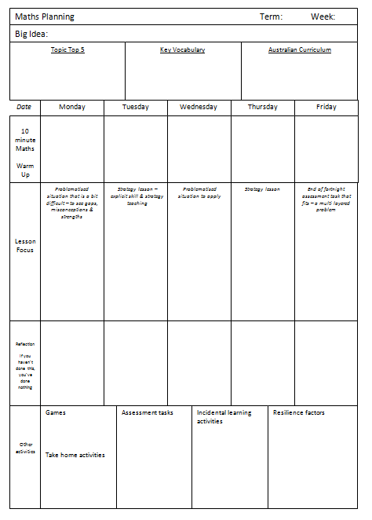
PLANNING
Planning for this structure of learning can be organised using the ‘Natural Maths Planning Tool’ where these problems are described as ‘problematised situations’. The idea is to use a combination of problems and explicit teaching and learning on the same concepts so that students are involved in learning the ‘pure’ maths (the skills, understanding, concepts) and then applying it to a situation where they need to use this maths.
This allows learning to be constantly responsive to student understanding all of the time. By realising, through formative assessment, what explicit teaching needs to happen next in order for their understanding to be extended. This planning is normally done by me on a day to day basis depending on the responses of the students during the day.

LEARNING
There are four main components to the Problem Solving strategy including the problem, strategies, samples and reflection. Students are explicitly taught the meaning behind each of the components and what skills are involved in each of these. For example, time is spent on discussing suitable ‘strategies’ when problem solving. These strategies are brainstormed, practised and highlighted when learning so that students are able to a) identify when they are using a particular strategy and b) learn to use and apply new strategies.
Problem: ‘What is the problem that we are working on and how does it connect to our maths learning? What is the ‘maths’ that we are going to need to use to solve this problem?’
Strategies: ‘What strategies can I use to best solve this problem? What can I do if my first ideas don’t work out? What is the best way that I can work out this problem?’
Samples: ‘Let’s look at how some people worked on the problem. What strategies did they use well? How are they different from your strategies? Is there a strategies that you thought was the most effective that you might try yourself next time?’
Reflection: ‘What did you learn today when solving this problem? What worked well and what will you try next time? What didn’t work well that you think you might change next time? What learning do you need to do in order to solve a problem similar to this?’

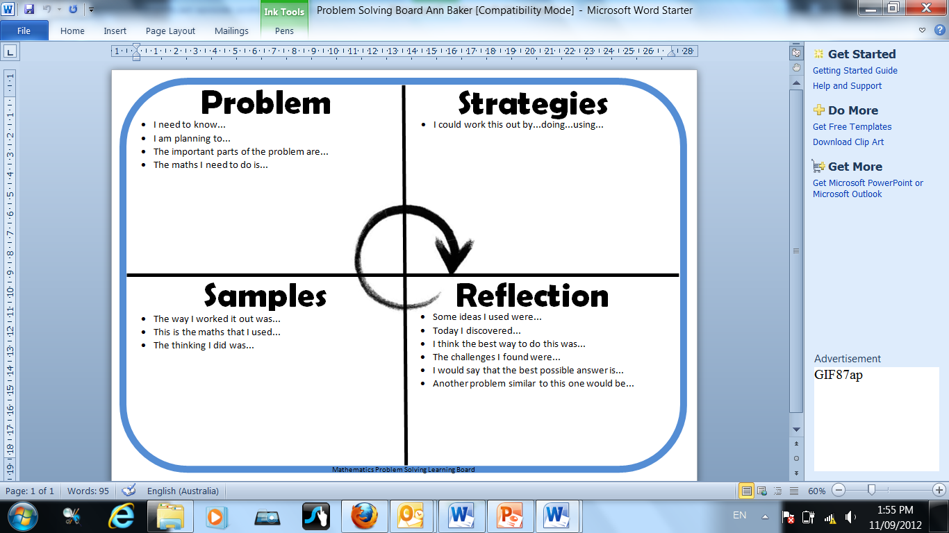

This ‘Problem Solving Board’ exists in a number of ways in the classroom. Each of the headings are labelled on one of the walls in the classroom allowing space underneath each one. Underneath the PROBLEM I attach a copy of the problem/s that we have solved. Underneath the STRATEGIES we put a brainstorm of the different strategies that were used during the learning, for example, worked with a friend, drew a table, used counters, etc. Underneath SAMPLES we attach 3-4 samples of student work that show different ways of working out. Underneath REFLECTION we write out the answers that we found and articulate how we found them and why we think this is the best possible answer. This is normally done on our samples or on post-it notes.
In the Upper Primary classes we have also made multiple copies of the above board on A3 laminated paper. When working through a problem they record their learning on post-it notes and stick it on the board or they can set up their paper like this as well under the 4 main headings.
Through this process we are explicitly going through the stages of problem solving.
“Stuck? Good! It was worth coming in today!” When coming
ASSESSMENT
In order to keep record of the learning that students do during this time (as it is rarely in concrete form in their books) I make sure I do the following:
- Collecting work samples in folder with student names labelled
- Students write reflections on their work samples articulating their learning, what they found out and what strategies were used, etc.
- Keep anecdotal notes on their learning when working with students

USEFUL RESOURCES
These resources developed by Ann and Johnny Baker are used for examples of problems that can be used.
http://naturalmaths.com.au/home.html
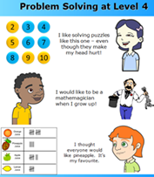

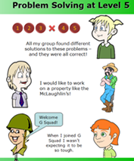
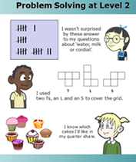
REFLECTION
Students are challenged in their thinking all of the time.
They occasionally have responses like I can’t do this, I don’t know what to do, this is too hard, etc. Although, over time when talking about strategies and useful ways of working and possibilities for answers, these barriers eventually were broken down and their response time during explorations and beginning to work out problems. During observations on particular kids that had this initial response, I noticed that the negative responses slowly went away and the time that they took to make a decision about where to start and what to get in order to help them became lower. Without the pressure on ‘answers’ and instead having the focus on ‘possibilities’ the fear of being wrong went away and students were more willing to share their possibilities knowing that these could be justified and they could give reasons for their possibilities, without just a simple yes or no or correct or incorrect.

