Early Years Learning in Mathematics community

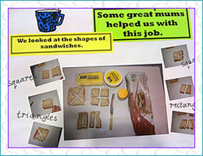
Professional Learning Resource

Sandwich Shapes
Gabby likes to have a sandwich for lunch. Every day her mum makes a sandwich for her to take to school, but Gabby is a mathematician and likes her mum to cut her sandwich into different shapes.

Enquiry learning
How many different ways could you cut and name the shapes for Gabby’s sandwich?
How many pieces of bread would Gabby need for her lunch for one week?
How much might her sandwich cost?
Teachers should comprehend what students need to understand before and after this task. As part of the community other educators can make suggestions to similar tasks, pre-tasks and tasks that will scaffold students' understanding once they have developed this concept.
Especially, in the early years, mathematical tasks need to be hands on, often designed to develop understanding of the same concept. Effective teachers often repeat an activity in a similar way with different materials.
As other educators share ideas in this conversation or with other ideas, a specialised language teachers use to support numeracy with young children will also assist their’ pedagogical content knowledge.
This community can support the sharing of these ideas through conversations, sharing of ideas, resources, photos and descriptions of numeracy tasks.

Community shared resource – Sharyn Livy, Early Years Mathematics Specialist

