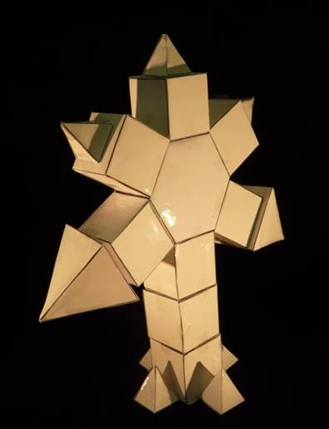
Unit 1A: Shape and Sculpture

Year Levels: 6 & 7
Teacher: Iain Hand
Alberton Cluster
Alberton Primary School DECD SA

Term 2 Overview
Timing | Topics | Learning Outcomes  National Curriculum | Activities | Assessment
Week 1 | 2 Dimensional Shape | Describes and draws two-dimensional  shapes, with and without digital technologies.  Compares the areas of regular and irregular shapes by informal means.  Compares and describes two-dimensional shapes that result from combining and splitting common shapes, with and without the use of digital technologies. | Discuss & demonstrate different 2 dimensional shapes. Students practice drawing and identifying polygons, quadrilaterals and parallelograms. Students classify and describe 2 Dimensional shapes and measure sides of shapes using a protractor. Create an artwork using polygons based on Paul Klee’s ‘The Castle and Sun.’ | - Teacher observations.  - Work samples.  - Shared learning.  - Individual & group conferencing.
Week 2 | 3 Dimensional Shape** | Describes the features of three-dimensional objects.  Connects three-dimensional objects with their nets and other two-dimensional representations.  Draws different views of prisms and solids formed from combinations of prisms | Discuss & demonstrate different 3 dimensional shapes. Students practice drawing and identifying prisms and pyramids. Students classify and describe 3 Dimensional shapes. Students draw models using 3 dimensional shapes for use in abstract sculpture project. | - Teacher observations.  - Work samples.  - Shared learning.  - Individual & group conferencing.  - Photographs.
Week 3 | 3 Dimensional  Sculpture | Makes models of three-dimensional objects and describes key features.  Connects three-dimensional objects with their nets and other two-dimensional representations. | Students collectively produce criteria for sculpture project. Using nets of chosen 3 Dimensional shapes, students begin to construct their abstract sculptures based on assessment criteria. | - Teacher observations.  - Work samples.  - Shared learning.  - Individual & group conferencing.  - Photographs.
Week 4 | 3 Dimensional  Sculpture | Makes models of three-dimensional objects and describes key features.  Constructs simple and complex prisms and pyramids. | Using nets of chosen 3 Dimensional shapes, students begin to construct their abstract sculptures based on assessment criteria. | - Teacher observations.  - Shared learning.  - Individual & group conferencing.  - Photographs.  - Peer & self assessment based on shared criteria.

Week 5 | 3 Dimensional  Sculpture* | Makes models of three-dimensional objects and describes key features.  Constructs simple and complex prisms and pyramids. | Using nets of chosen 3 Dimensional shapes, students begin to construct their abstract sculptures based on assessment criteria. Students write a description of their sculpture including a title, its meaning & the number of faces, edges and corners used in its construction. | - Teacher observations.  - Shared learning.  - Individual & group conferencing.  - Photographs.
Week 6 | 3 Dimensional  Sculpture* | Makes models of three-dimensional objects and describes key features.  Constructs simple and complex prisms and pyramids. | Using nets of chosen 3 Dimensional shapes, students begin to construct their abstract sculptures based on assessment criteria. Students write a description of their sculpture including a title, its meaning & the number of faces, edges and corners used in its construction. | - Teacher observations.  - Shared learning.  - Individual & group conferencing.  - Photographs.
Week 7 | 3 Dimensional  Sculpture* | Makes models of three-dimensional objects and describes key features.  Constructs simple and complex prisms and pyramids. | Using nets of chosen 3 Dimensional shapes, students finish constructing their abstract sculptures based on assessment criteria. Students display their sculptures & using the criteria already developed, students self assess theirs and all other class member’s sculptures. | - Teacher observations.  - Work samples.  - Shared learning.  - Peer & self assessment based on shared criteria.  - Photographs.
Week 8 | Perspective Drawing** | Draws different views of prisms and solids formed from combinations of prisms. | Students draw their abstract sculptures in one & two point perspective & display finished drawing. | - Teacher observations.  - Work samples.  - Shared learning.  - Individual & group conferencing.  - Photographs.
** Perspective drawing was taught to the class prior to this unit.
Assessment Criteria: 3D Sculpture
Achievement Level | Level descriptor
0 | The student does not reach the standard described by any of the descriptions below.
1 | A few shapes put together.  Shapes not folded correctly.  Shapes squished & dented.  Under 4 pieces used.  Sculpture not close to completion.  No label.
2-3 | Sculpture close to completion.  Shapes not stuck together correctly.  Shapes squished & dented.  Artist has made an attempt to finish.  Attempted to write label.  Description of sculpture is unclear.
4-5 | Used cartridge paper as second layer for nets.  Shapes stuck together securely.  At least 50% of faces, edges & corners included.  Only some imperfections in construction.  Sculpture is named and labelled.  Description of sculpture is a little unclear.
6-7 | Used cartridge paper as second layer for nets.  Shapes stuck together securely.  Only some imperfections in construction.  At least 75% of faces, edges & corners included.  Sculpture is named and labelled with accurate spelling.  Description of sculpture is clear & understood.
8-9 | Used cartridge paper as second layer for nets.  Shapes stuck together securely.  Clean construction, neat joins.  At least 90% of faces, edges & corners included.  Sculpture is named and labelled with accurate spelling.  Description of sculpture is clear using the language of Visual Arts.
10 | Used cartridge paper as second layer for nets.  Shapes stuck together securely.  Clean construction, neat joins.  At least 100 faces, 100 edges & 100 corners included.  Sculpture is named and labelled with accurate spelling.  Description of sculpture is clear using the language of Visual Arts.

